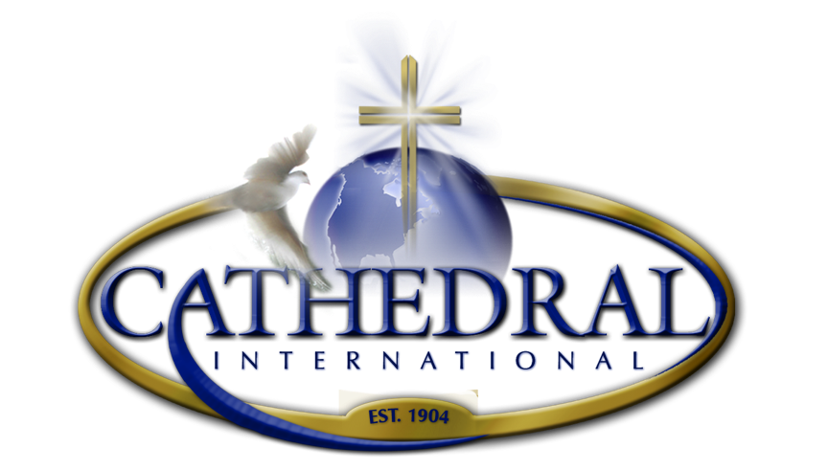

PHOTO/VIDEO RELEASE FORM

Child’s Name: ___________________________________________________________

Parent/Legal Guardian Name:___________________________________________________________________
(Please Print Clearly)

Parent/Legal Guardian Cell Number: ________________ Email:____________________

I freely sign this Agreement and Release of Liability Form. Photo/Video Release and I hereby grant Cathedral International permission to use my photograph/video image in any and all publications for Cathedral International including website and social media entries, without payment or any other consideration in perpetuity. I hereby authorize Cathedral International to edit, alter, copy, exhibit, publish, or distribute all photos and images. I waive the right to inspect or approve the finished product, including a written or electronic copy, wherein my photo appears. Additionally, I waive any right to royalties or other compensation arising or related to the use of the photograph or video images. I hereby hold harmless and release and forever discharge Cathedral International from all claims, demands, and causes of action which I, my heirs, representatives, executors, administrators, or any other persons acting on my behalf or on behalf of my estate may have.

I have read the above photo/video release and fully understand its contents. I voluntarily agree to the terms and conditions stated above. *

Parent/Legal Guardian Signature:____________________________________________________ Date:___/___/_____

Thank you for your participation, God bless you.

